Classification of Modulation Techniques
Modulation Techniques can be broadly classified as follows:
- Digital versus Analog Modulation
- Baseband versus Bandpass (Passband) Modulation
- Binary versus M-ary Modulation
- Memoryless Modulation versus Modulation with memory
- Linear versus Nonlinear Modulation
- Constant envelope versus Non-constant envelope Modulation
- Power efficient versus Bandwidth efficient Modulation
Baseband versus Bandpass Communications
Baseband (Lowpass):
A signal whose frequency content (i.e. its spectrum) is in the vicinity of zero (i.e., f = 0 or dc) is said to be a baseband signal. Original source signal are sometimes said to be baseband. Baseband systems transmit baseband signals. This is usually not an effective means of communication. Why?
Bandpass (Passband or Narrowband):
Bandpass signal spectrum is nonzero in some band of frequency with BW = 2B centered about f = ±fc, where fc >> 0. fc is carrier frequency. Effective transmission of signal usually requires bandpass signal.
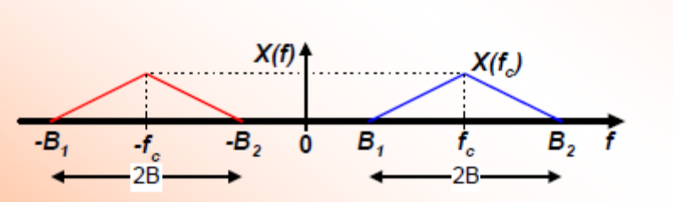
Bandpass transmission involves some translation of the baseband signal to some band of frequency centered around fc.

Bandpass Transmitter:
Carrier (high frequency pure sinusoidal generated by the local oscillator) is altered in response to a given low frequency signal (message signal) generated by the source. Coupling EM wave into space - antenna size a wavelength.
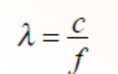
For speech signal f = 3 kHz & 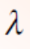 = 105. Antenna size without modulation = 105m = 60 miles. Practically unrealizable. Hence, efficient antenna of realistic physical size is needed for radio communication system.
Information signal must conform to the limitation of its channel(channel matching). Reduce the effect of interference, e.g. Spread Spectrum. Place signals at desired frequency band for signal processing purposes such as filtering, amplification, multiplexing. Used to map digital information sequence into waveforms
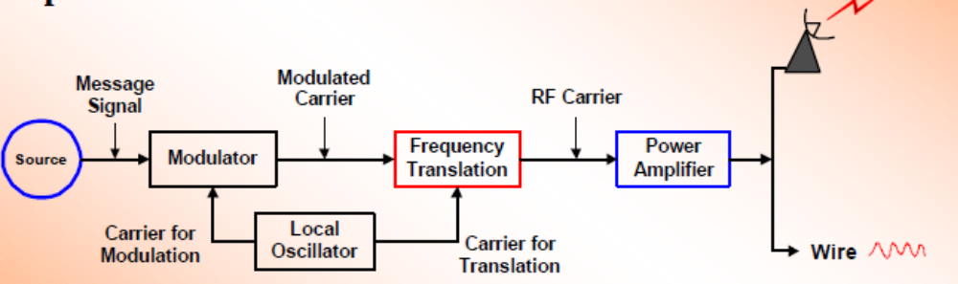

Definition of Modulation
The technique of superimposing the message signal on the carrier is known as modulation
That is, modulation is the process by which a property or parameter of one signal (in this case the carrier) is varied in proportion to the second signal (in this case the message signal). Modulation is performed at the transmitter, and the reverse operation (demodulation/detection) is performed at the receiving end.
Let m(t) = message (or information) signal, c(t) = carrier signal, s(t) = modulated signal (transmitted signal)
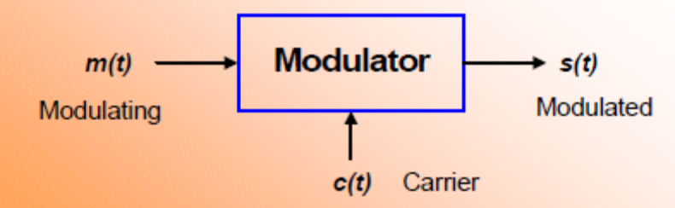
The carrier c(t) is a pure sinusoidal signal generally given as
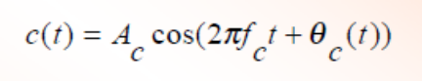
Examination of c(t) indicate that there are 3 parameters which may be varied:
1. The amplitude Ac,
2. The frequency fc, and
3. The phase qc(t)
These parameters can be varied in Analog or Digital form. When varied in Digital form, it is referred to as “Shifting & Keying”.

Digital Modulation Techniques (Sample)
The purpose of digital modulation is to convert an information-bearing discrete-time symbol into a continuous-time waveform.
Basic Techniques (Binary, M = 2):
Common binary modulation schemes include
- Amplitude Shift Keying (BASK)
- Frequency Shift Keying (BFSK)
- Phase Shift Keying (BPSK)
- Differential Phase Shift Keying (DPSK)
For M > 2, many variations of the above techniques exist usually classified as M-ary modulation
- M-ary modulation schemes include
  - Phase Shift Keying (MPSK)
    - Quadrature Phase Shift Keying (QPSK)
    - Offset QPSK (Staggered QPSK) (OQPSK/SQPSK)
    - π/4 Differential QPSK (no carrier) (π/4 DQPSK)
    - π/4 Differential QPSK (with carrier) (π/4 QPSK)
    - Differential MPSK (no carrier recovery) (DMPSK)

    - Continuous-Phase Frequency Shift Keying (CPFSK)
    - Sinusoidal Frequency Shift Keying (SFSK)
    - Minimum Shift Keying (MSK)
    - Differential MSK (DMSK)
    - Gaussian MSK (GMSK)
    - Amplitude Phase Keying (MAPK)
    - Quadrature Amplitude Modulation (MQAM)
    - Superposed QAM
    - Quadrature Partial Response Signaling (QPRS)

Digital Detection Techniques
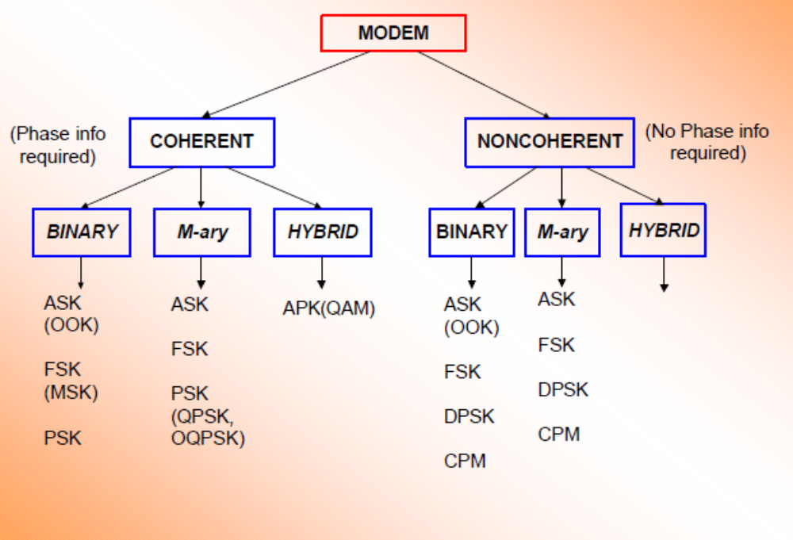

Amplitude Shift Keying (ASK)
Modulation Process: Amplitude of the carrier is switched between two (or more) levels according to the digital data.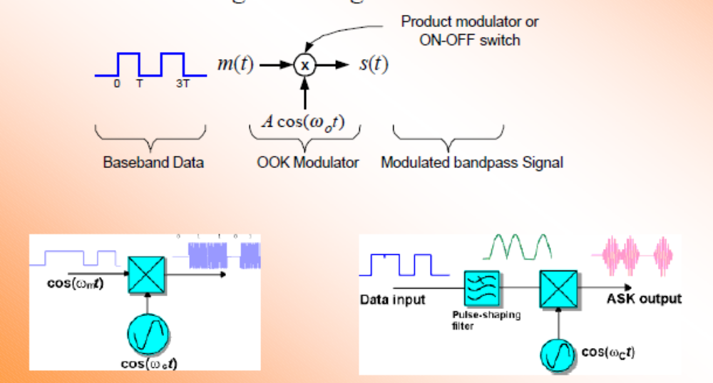

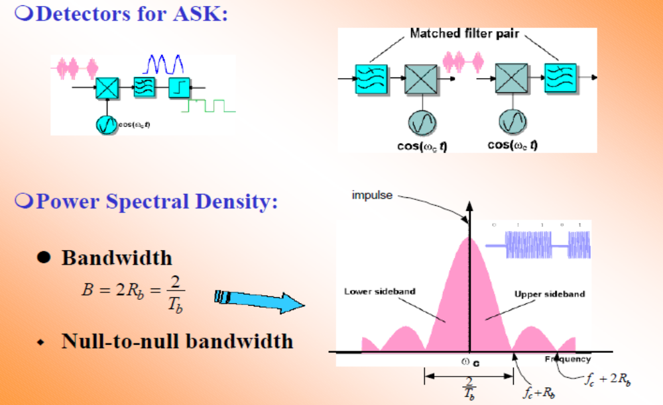
Frequency Shift Keying (FSK)
Modulation Process: In FSK, the instantaneous frequency of the carrier is switched between 2 or more levels according to the baseband digital data
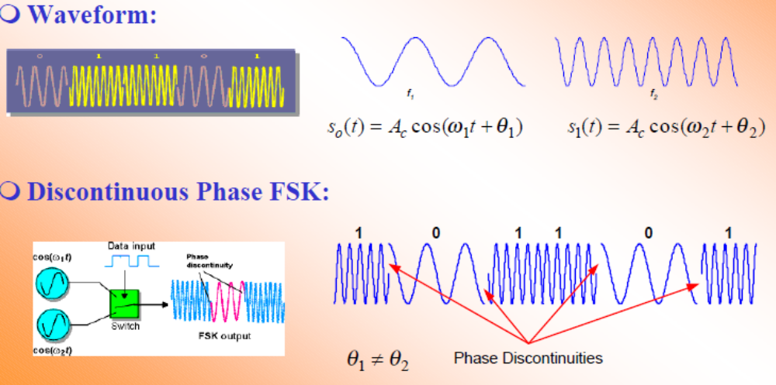

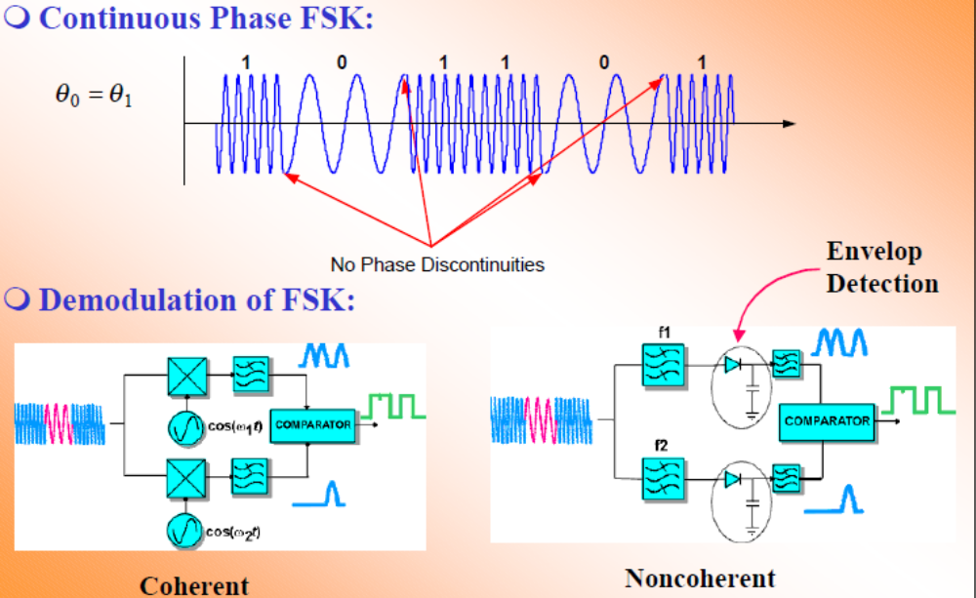

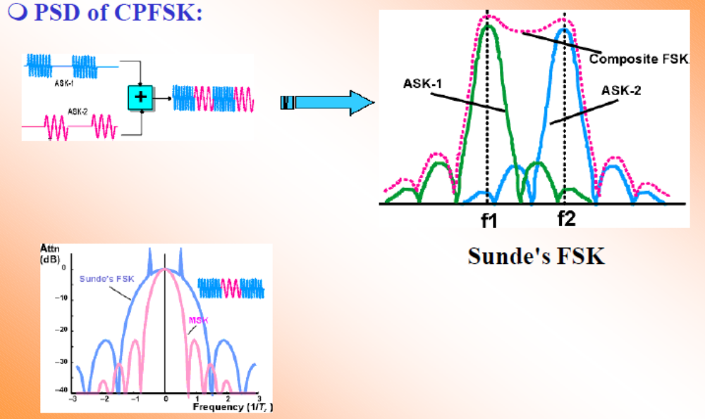

Phase Shift Keying (PSK)
Modulation Process: In PSK, the phase of the carrier signal is switched between 2 or more values in response to the baseband digital data
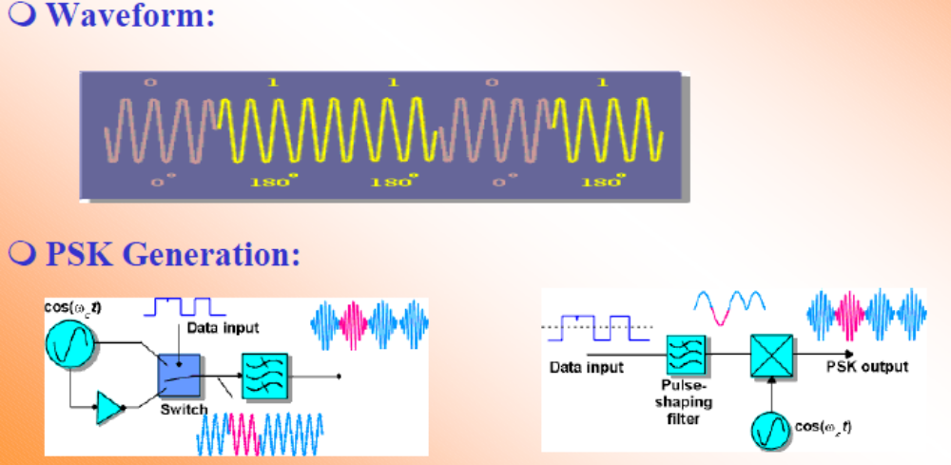

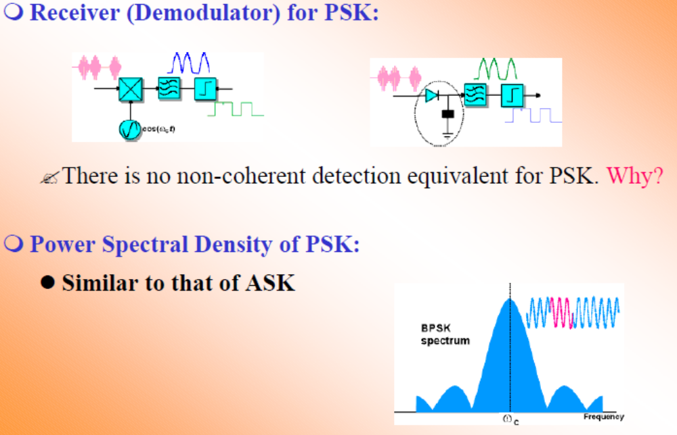

Quadrature PSK
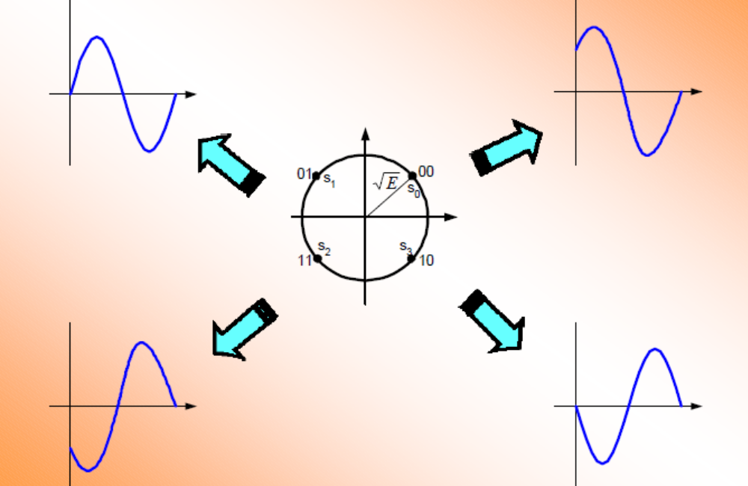

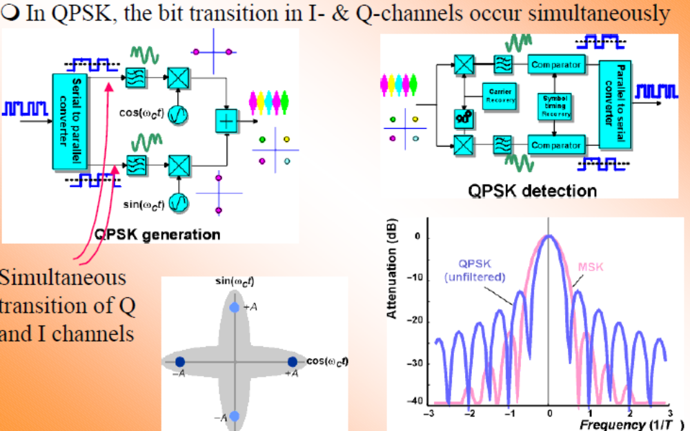

Offset of QPSK
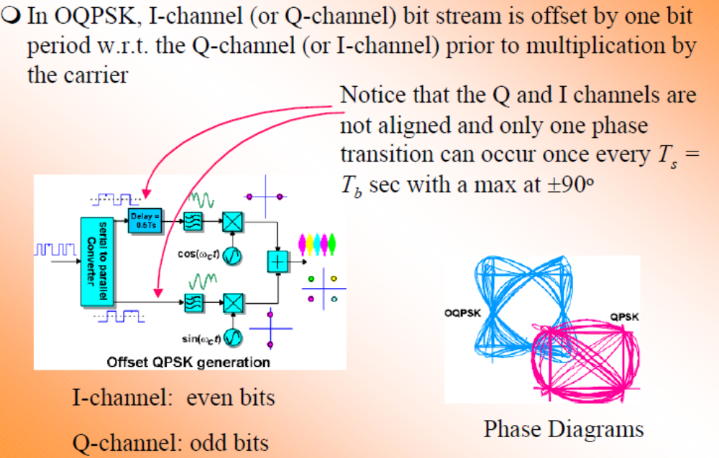

Differential PSK
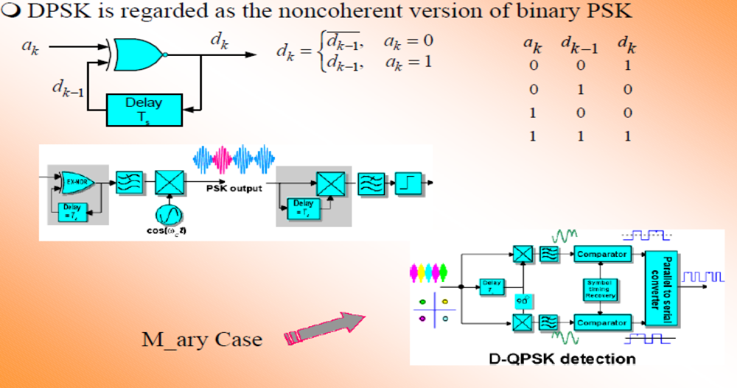

Quadrature Amplitude Modulation (QAM)